Guideline for adding Radar Charts
in customized Report Card Template P

Adding radar charts in report template of report card P

Brief Description

In built-in report card templates, there is no chart for analysis in subjects. However, based on flexible design of report card P, we can add charts to solve this problem. This guideline serves the purpose for users want to adding radar charts in built-in report card P template.

Pre-conditions

- The user must have access right to Report Management module.
- The user must have access right to School Management module.
- The user must have access right to WebSAMS report server machine.
- The user is expected a crystal report user at intermediate level.

Step 1. Create School-based subjects in School Management Module.
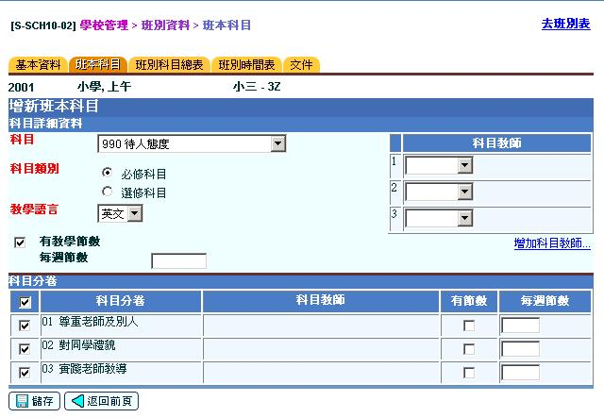
Step 2. Edit the subreport to modify the template to fit users’ setting. Double click the subreport subject1.
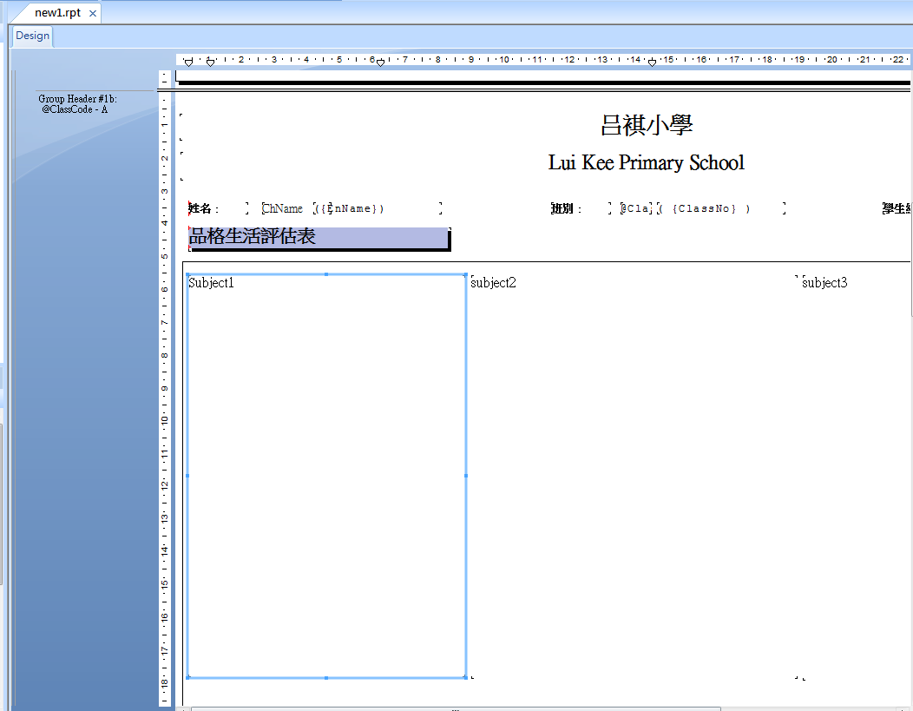

Step 3. In the subreport window, click the Select Expert on tool bar.
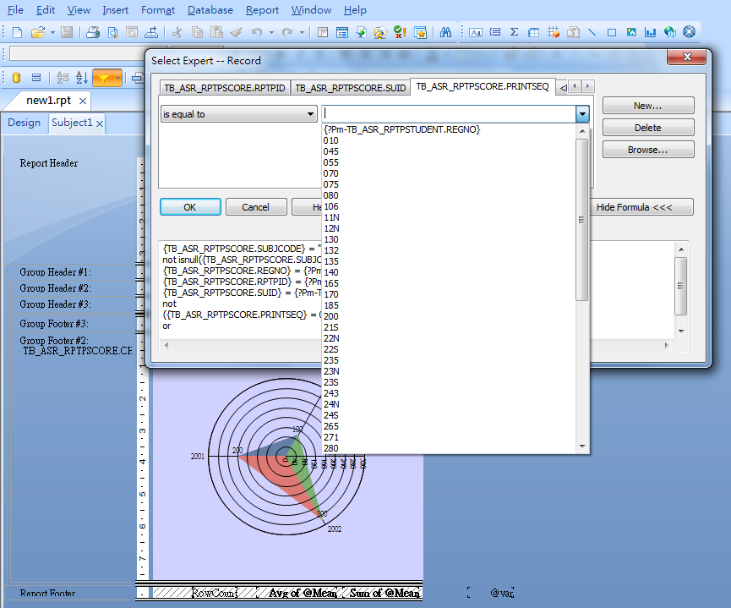

Select the porper subject code from the pull down menu. Press OK and close the Select Expert. Repert the step in the subreport2 and subreport 3.

Step 4. Upload the report card P template to WebSAMS from Report Management module.
